[](https://de.dreamstime.com/stockfotografie-meine-groeltern-image686302)[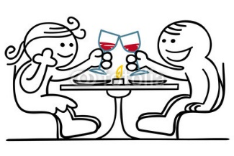](https://www.google.ch/url?sa=i&rct=j&q=&esrc=s&source=images&cd=&cad=rja&uact=8&ved=0ahUKEwjWve-R4LzPAhUTnRQKHSRCC5cQjRwIBw&url=https://sagniemalsholeroe.wordpress.com/tag/essen/&bvm=bv.134495766,d.ZGg&psig=AFQjCNFZdXjJLTnVuGvX4KWuAORCEGu0Cg&ust=1475519358021871)[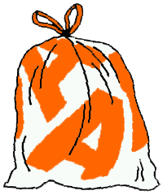](http://www.google.ch/url?sa=i&rct=j&q=&esrc=s&source=images&cd=&cad=rja&uact=8&ved=0ahUKEwiQ97HD4rzPAhXMvBQKHUlHBvoQjRwIBw&url=http://www.a-region.ch/index1.html&bvm=bv.134495766,d.ZGg&psig=AFQjCNHpJ8JHxQMOLDiswgV3hFUoF3GeEA&ust=1475519972383190)[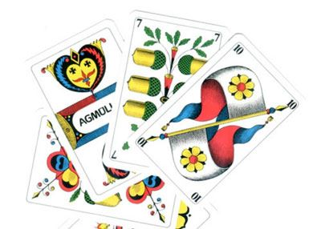](http://www.google.ch/url?sa=i&rct=j&q=&esrc=s&source=images&cd=&cad=rja&uact=8&ved=0ahUKEwjW9N_94LzPAhXJOBQKHVxrBrkQjRwIBw&url=http://www.restaurantbraui.ch/content/events/&bvm=bv.134495766,d.ZGg&psig=AFQjCNGRDcmaJNarcYlDn3g7EDcPndQ8Jg&ust=1475519416214907)

[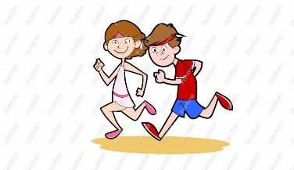](http://www.google.ch/url?sa=i&rct=j&q=&esrc=s&source=images&cd=&cad=rja&uact=8&ved=0ahUKEwj3puKU37zPAhWJvhQKHQbmCTIQjRwIBw&url=http://www.clipartkid.com/person-jogging-cliparts/&bvm=bv.134495766,d.ZGg&psig=AFQjCNF9gicPxWTKeroxRK_0DLwXChnRhA&ust=1475519038946265)

[](http://www.google.ch/url?sa=i&rct=j&q=&esrc=s&source=images&cd=&cad=rja&uact=8&ved=0ahUKEwia-MGm8bzPAhUGcRQKHftVD7kQjRwIBw&url=http://www.westwerk141.de/index.php/component/jem/event/382-tanzen-tanzen-tanzen&bvm=bv.134495766,d.ZGg&psig=AFQjCNGePGU24cfM6YnNFxfEHkFMAemxUg&ust=1475523960845216)[](http://www.google.ch/url?sa=i&rct=j&q=&esrc=s&source=images&cd=&cad=rja&uact=8&ved=0ahUKEwjJ7KzXm7zPAhWJ6RQKHR0wBZkQjRwIBw&url=http://ludo.mihei.ch/informationen/oeffnungszeiten&bvm=bv.134495766,d.d24&psig=AFQjCNHW-MWpLb0dEzm57EHa4XvMHZVWdQ&ust=1475500963723206)[](http://www.google.ch/url?sa=i&rct=j&q=&esrc=s&source=images&cd=&cad=rja&uact=8&ved=0ahUKEwirzNmQ3rzPAhVFWRQKHdevDocQjRwIBw&url=http://www.fotosearch.de/clip-art/radfahrer.html&bvm=bv.134495766,d.ZGg&psig=AFQjCNFiQ19NykRd_zFQ91r6i6PNFd2WuQ&ust=1475518822747649)

[](http://www.google.ch/url?sa=i&rct=j&q=&esrc=s&source=images&cd=&cad=rja&uact=8&ved=0ahUKEwj82b7h5bzPAhXEtRQKHfmhBpIQjRwIBw&url=http://geschenkfuropa.de/uberblick/bei-opa-75-jahre-zu-hause/&bvm=bv.134495766,d.ZGg&psig=AFQjCNFppThHEN_Qx6DFzBm2owQ43TRpgA&ust=1475520836584210)[](http://www.google.ch/url?sa=i&rct=j&q=&esrc=s&source=images&cd=&cad=rja&uact=8&ved=0ahUKEwia-MGm8bzPAhUGcRQKHftVD7kQjRwIBw&url=http://www.westwerk141.de/index.php/component/jem/event/382-tanzen-tanzen-tanzen&bvm=bv.134495766,d.ZGg&psig=AFQjCNGePGU24cfM6YnNFxfEHkFMAemxUg&ust=1475523960845216)[](http://www.google.ch/url?sa=i&rct=j&q=&esrc=s&source=images&cd=&cad=rja&uact=8&ved=0ahUKEwiF-9rr5rzPAhWBvhQKHdUiAEwQjRwIBw&url=http://publicdomainvectors.org/de/kostenlose-vektorgrafiken/Einfaches-Boot-Vektorgrafik/8462.html&bvm=bv.134495766,d.ZGg&psig=AFQjCNHBxD8XQvTpTvcAzOU_exTghBzBiQ&ust=1475521124937230)[](http://www.google.ch/url?sa=i&rct=j&q=&esrc=s&source=images&cd=&cad=rja&uact=8&ved=0ahUKEwjwgNfM47zPAhXExxQKHWWFCAkQjRwIBw&url=http://www.energie-umwelt.ch/haus/garten/kompost&bvm=bv.134495766,d.ZGg&psig=AFQjCNFSyurq_oJpwpUyE043zmZp5okx8w&ust=1475520293808633)

[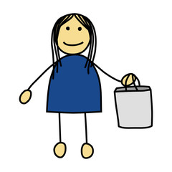](https://www.google.ch/url?sa=i&rct=j&q=&esrc=s&source=images&cd=&cad=rja&uact=8&ved=0ahUKEwijot2v7bzPAhVBnBQKHReGAc0QjRwIBw&url=https://de.fotolia.com/tag/einkaufsbeutel&bvm=bv.134495766,d.ZGg&psig=AFQjCNEH9xgKVeMq-j1ADYET8sCaTzQ-sg&ust=1475522896139487)[](http://www.google.ch/url?sa=i&rct=j&q=&esrc=s&source=images&cd=&cad=rja&uact=8&ved=0ahUKEwiT69W28rzPAhXD6xQKHbh7DuMQjRwIBw&url=http://www.365-tage-kreativ.de/tag/cartoon/&bvm=bv.134495766,d.ZGg&psig=AFQjCNH0OSFIkIwUW2b-RT-MEuesQBukdA&ust=1475524248509659)[](http://www.google.ch/url?sa=i&rct=j&q=&esrc=s&source=images&cd=&cad=rja&uact=8&ved=0ahUKEwiv-bmS6LzPAhVH7RQKHVncCG0QjRwIBw&url=http://www.istockphoto.com/ch/grafiken/meerschweinchen&bvm=bv.134495766,d.ZGg&psig=AFQjCNG8orqmrL62aA_6Avo43gJOSxXYJw&ust=1475521497715598)[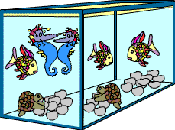](http://www.google.ch/url?sa=i&rct=j&q=&esrc=s&source=images&cd=&ved=0ahUKEwiaw96r57zPAhUHcRQKHaLIAJEQjRwIBw&url=http://www.kidsweb.de/tiere/aquarium_spezial/aquarium_spezial.html&bvm=bv.134495766,d.ZGg&psig=AFQjCNGJvjbajQg_DVHbuAGq-4ax30O1ow&ust=1475521264088639)

[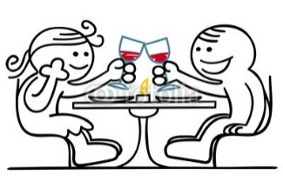](https://www.google.ch/url?sa=i&rct=j&q=&esrc=s&source=images&cd=&cad=rja&uact=8&ved=0ahUKEwjWve-R4LzPAhUTnRQKHSRCC5cQjRwIBw&url=https://sagniemalsholeroe.wordpress.com/tag/essen/&bvm=bv.134495766,d.ZGg&psig=AFQjCNFZdXjJLTnVuGvX4KWuAORCEGu0Cg&ust=1475519358021871)[](http://www.google.ch/url?sa=i&rct=j&q=&esrc=s&source=images&cd=&cad=rja&uact=8&ved=0ahUKEwj3puKU37zPAhWJvhQKHQbmCTIQjRwIBw&url=http://www.clipartkid.com/person-jogging-cliparts/&bvm=bv.134495766,d.ZGg&psig=AFQjCNF9gicPxWTKeroxRK_0DLwXChnRhA&ust=1475519038946265)[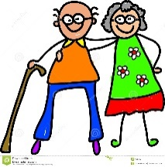](https://de.dreamstime.com/stockfotografie-meine-groeltern-image686302)[](https://www.google.ch/url?sa=i&rct=j&q=&esrc=s&source=images&cd=&cad=rja&uact=8&ved=0ahUKEwijot2v7bzPAhVBnBQKHReGAc0QjRwIBw&url=https://de.fotolia.com/tag/einkaufsbeutel&bvm=bv.134495766,d.ZGg&psig=AFQjCNEH9xgKVeMq-j1ADYET8sCaTzQ-sg&ust=1475522896139487)

[](http://www.google.ch/url?sa=i&rct=j&q=&esrc=s&source=images&cd=&cad=rja&uact=8&ved=0ahUKEwj82b7h5bzPAhXEtRQKHfmhBpIQjRwIBw&url=http://geschenkfuropa.de/uberblick/bei-opa-75-jahre-zu-hause/&bvm=bv.134495766,d.ZGg&psig=AFQjCNFppThHEN_Qx6DFzBm2owQ43TRpgA&ust=1475520836584210)[](http://www.google.ch/url?sa=i&rct=j&q=&esrc=s&source=images&cd=&cad=rja&uact=8&ved=&url=http://pixers.de/fototapeten/suchen/b%C3%BCx&bvm=bv.134495766,d.ZGg&psig=AFQjCNHz6AE02YNVRtzOdtfF_UjJzJLsJw&ust=1475523208432798)[](http://www.google.ch/url?sa=i&rct=j&q=&esrc=s&source=images&cd=&cad=rja&uact=8&ved=0ahUKEwirzNmQ3rzPAhVFWRQKHdevDocQjRwIBw&url=http://www.fotosearch.de/clip-art/radfahrer.html&bvm=bv.134495766,d.ZGg&psig=AFQjCNFiQ19NykRd_zFQ91r6i6PNFd2WuQ&ust=1475518822747649)[](https://www.google.ch/url?sa=i&rct=j&q=&esrc=s&source=images&cd=&cad=rja&uact=8&ved=0ahUKEwjs5o3f77zPAhXLthQKHX3pAbkQjRwIBw&url=https://www.vectorstock.com/royalty-free-vector/colorful-meeting-ongoing-icon-vector-4102865&bvm=bv.134495766,d.ZGg&psig=AFQjCNG4yONZt-kDCL_bOWqv73MbEoGPAw&ust=1475523526984836)